QUOTATION

Payment: 100% with the order
Date:
14/10/2022

Photo | Specification | Packing | NW/GW (KG) | Carton Meas (cm) | QTY | Total  weight (KG) | Total CBM | Delivery time | FOB Price USD
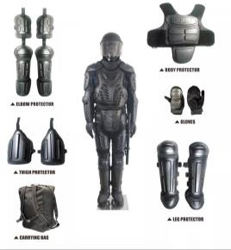 | - SIZE: One-size-fits-all.  - Material: ABS + EVA.  - Color: Black  - Feature:  . Ergonomical design.  . Innocuous material.  . High-wearing feature.  . Best impact absorption.  . Soft EVA for more comfortable. | 1pcs/ctn | 10/11 | 49*31*61 | 5000 | 55000 | 463 | 45days | 292
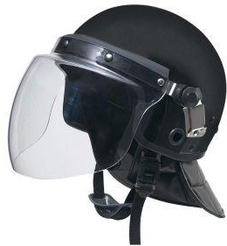 |  | 9pcs/ctn | 16/17 | 86*82*36 | 5000 | 9445 | 141 | 45days | 40
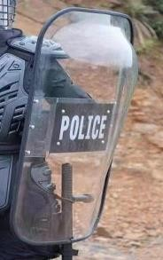 | Material: PC transparent with cushioned diagonal ellbow rail and anti-slip handle.  Shape: rectangular.  size: 1000X560X3.5mm about3.5kg/pc | 5pcs/ctn | 17/18 | 120*58*30 | 5000 | 18000 | 209 | 45days | 55

